Notable People of San Antonio in 2020 Collection

Image Release and Usage

KGS Studios is creating a collection of portraiture of notable individuals in San Antonio. We plan on creating a physical portrait collection to be displayed publicly and promoting the collection online and through earned media.

All images and digital files remain the exclusive property of the studio. The studio reserves the right to use any images created for display, promotion and advertising.

All images and products are protected under copyright laws, and may not be reproduced or transmitted electronically without a specific licensing agreement provided by the studio.

Honorees will get a complimentary 8 x 10 print on gelatin silver photographic paper plus an internet sized image. No purchase is necessary to be part of the collection.

Some people and corporations may wish to purchase additional portraits and frames which will be offered at our Signature Portrait standard published pricing. If an honoree wishes to upgrade their portrait print, they will have a $2,000 print credit.

If an honoree, other individual, or corporation purchases a portrait from this collection, KGS Studios will donate 10% of the proceeds to the charity of the Honoree’s choice, in their name.

There is a planned exhibition in early 2021 to show the collection in its entirety. The Honoree will be invited to attend this event.

Date: ______________________

Name: ____________________________

Signed: ______________________________________________________

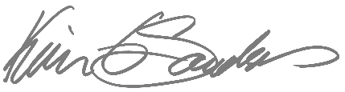

Kevin G Saunders
KGS Studios

